CSCI 4661

Dr. Ben Samuel

Ivan Zelenkov (idzelenk@uno.edu)

September 14, 2022

Competitive Analysis

While researching crypto apps on the App Store, I found that there are many good apps related to this topic, but most of them acted as crypto wallets where users can trade. So, mostly what they provide is the ability to trade crypto and keep users up to date about cryptocurrencies. I was looking for another kind of cryptocurrency-related app that would be like a helper app with cryptocurrencies. I could not find many reviews about those apps, but I am already seeing what should be improved to expand in that area.

I realized that I could improve existing features, add more, and present them all in a single application. And that can be something like a crypto social network, where users can not only observe statistics, but also read the news that includes videos, do calculations related to coins, communicate with each other, and work with mining which I found only in several apps. In an application where diagrams are one of the main elements, they should be drawn as quickly and correctly as possible, without any glitches. Problems with displaying and updating the diagram can lead to a very rapid increase in user dissatisfaction and lower ratings.

I discovered different apps from App Store like CryptoDaily, LiveCrypto, ProfiMine, Tokeo, and Delta and will go over each of them.

CryptoDaily *(Figure 1)* and LiveCrypto *(Figure 2)* are two applications that are almost similar.

CryptoDaily has a very basic design and glitching "Price" page. Previously when I was testing, I could open that page successfully, it was displaying just the usual statistics without any deep implementation like animated diagrams and being able to slide it. But right now, the CryptoDaily application just throws me back to the home screen after I tap on the "Price" section. "News" section is implemented in a very simple way, without any interesting design.

The same thing I can say about the LiveCrypto application is that there are very few features that would not hold users for a long time to use their application. In conclusion about these apps, I can say that they not only lack a lot of features and working parts, but also has a very basic design that does not attract users and does not feel great. I think that the improved design part and deeper implementation of the cryptocurrency features will attract much more users.

*Figure 1 (CryptoDaily application)*

*Figure 2 (LiveCrypto application)*

*Figure 3 (ProfiMine application)*

*

*Figure 4 (Delta application)*

*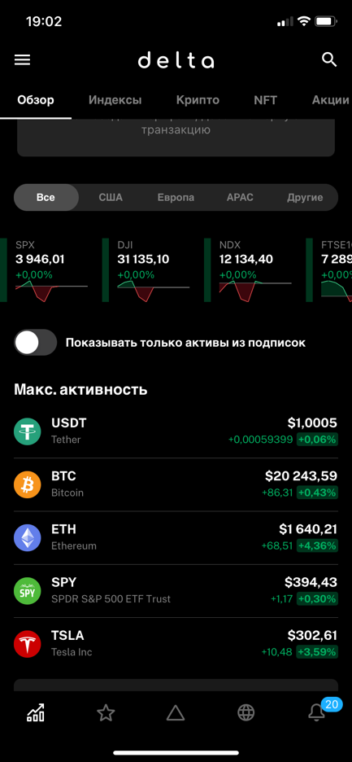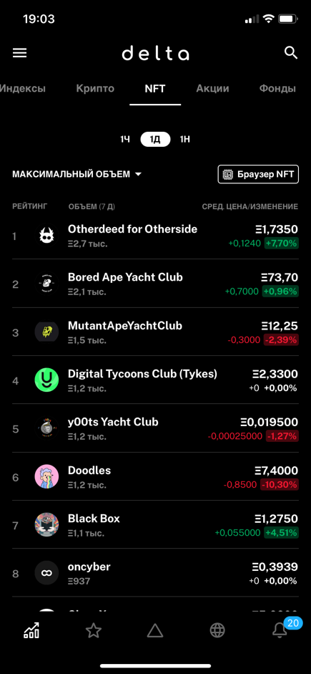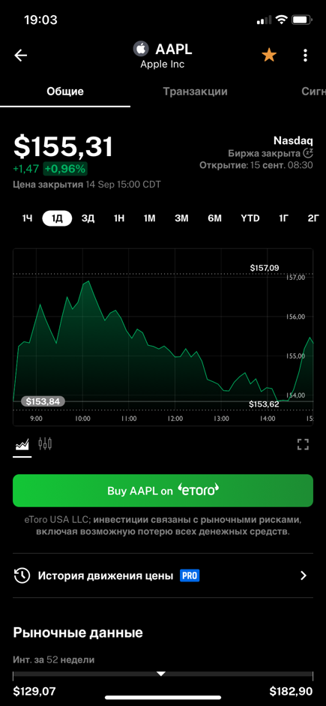*

ProfiMine *(Figure 3)* application includes a page that allows users to set the rig's hash rate settings, earning difficulty, and other data to see how much income will be generated from cryptocurrency mining. This feature is very interesting and not many apps provide it to users. It has a nice detailed crypto stats screen with a diagram, but the downside of their creation is that they imported the website directly into the app to display crypto data rather than building custom components to display it. The animations and design of the app don't look too professional. But I would like to say that this application meets more user needs than the previous two and it would be a good starting point to first develop something like that and then improve my app by adding more different features and design implementations.

Delta *(Figure 4)* application is the best app I have found, it provides the user with many great features such as displaying all statistics about cryptocurrencies, stocks, NFTs, news, the ability to add items to favorites, and explore more information about a specific NFT. But it does not provide features such as cryptocurrency and mining calculators, which are often used by people who work in this area. The design of the app looks great and there is only a dark theme. I think that I could also just add a dark interface and leave out the light one. It depicts all the items that are displayed very well, and they all actually caught by eyes much better than in light theme.

In conclusion, I learned a lot from discovering different applications. Each of them gave me a better understanding of what should be done and improved. CryptoDaily, LiveCrypto, and ProfiMine applications showed what can be finished at the first stage of development (statistics, news, crypto calculators, diagram features), and Delta application showed me what the stage two should be (add more pages like NFT, stocks, and refactoring of the design). This milestone was very helpful, and I found more things that can be created, improved, and how everything should be structured in the Apex application.